Boston QuarkNet Center
2025-2026 Annual Report

Fall Meeting – November 13, 2025.
For a change of pace, we held our fall meeting at Northeastern University this year. Prof. Darien Wood was traveling. So, Prof. Johan Bonilla Castro hosted us. The prospect of driving into the city and finding a place to park may have inhibited some from attending, but those who did attend (Mike Wadness, Scott Carlson, Mark Brooks Hedstrom, Ayo Awobode, and Rick Dower) enjoyed the conversation and insights discussed. Rick gave a wrap-up talk on Lagrangian principle in mechanics and showed how to do some simple examples. Prof. Bonilla Castro confirmed that the Lagrangian approach is what is commonly used in theoretical particle physics.

Following the presentation, we watched a Veritasium video by Derek Muller titled “The Strange Physics Principle That Shapes Reality” (https://www.youtube.com/watch?v=Q10_srZ-pbs&t=3s) about Fermat’s Least Time Principle and Maupertuis’ Least Action Principle, as amended by Euler and Lagrange.

Prof. Bonilla Castro then gave a presentation describing his path from high school to Northeastern and explained his interest in science teaching and communicating with a lay audience. Then he described recent results concerning the mass of the W boson and the muon g-2 value. The CDF analysis of all their Tevatron data produced a highly precise W mass value that differed substantially from other measurements and from calculations based on the Standard Model. The discrepancy prompted analysis of LHC data by the ATLAS and CMS groups. Their W mass measurements fell in line with earlier measurements and with calculations from theory. So, the CDF value remains an unexplained anomaly. The Fermilab muon g-2 value confirmed, at increased precision, an earlier Brookhaven result. More recent theoretical calculations shifted an earlier calculation result, so that theory and experimental measurement now overlap. We look forward to the Particle Physics Masterclass for students at Northeastern in March.

Particle Physics CMS Masterclass – March 28, 2026
This year’s Particle Physics CMS Masterclass on 3/28/2026 was smaller this year than last, but the interest and engagement was just as high. Our dozen students arrived with their teachers from St. Pauls’ School in New Hampshire and Medford and Needham High Schools here in Massachusetts. Teachers Mark Hermano, Mike Wadness, and Mike Hirsh, along with Rick Dower helped guide the students through the activities. After views of alpha particle tracks in a cloud chamber and cathode ray tracks influenced by magnetic fields and some get-acquainted exercises supervised by Mike Wadness, the students were treated to an introduction to the standard model, particle accelerators, and cosmology connections by a trio of Northeastern professors: Johan Bonilla Castro, Steven Kautsch, and our Mentor, Darien Wood. After a break for snacks, Mike Wadness gave the students an overview of the data analysis process for examining CMS collision data images. In addition, students got a look at a Northeastern physics lab where two grad students showed the liquid argon time projection chamber (LArTPC) that they were preparing for a balloon flight to examine cosmic rays.
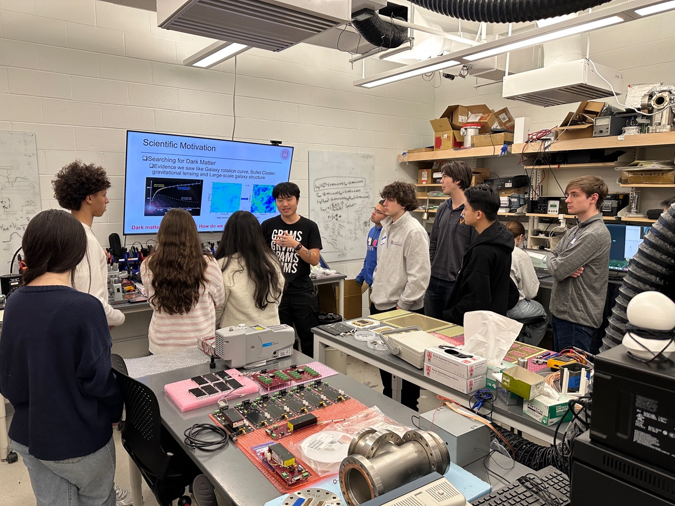
Northeastern grad student describing his cosmic ray experiment.

After that excursion, the high school students enjoyed “Lunch with a Physicist” in the Northeastern Student Center cafeteria. The opportunity to talk with physics professors and grad students about physics topics and about their career paths is always a highlight of the day.

Lunch was followed by a more detailed tutorial on CMS detector image analysis and some conversation about expected results of the afternoon’s data analysis. Each student pair analyzed about 100 event records and entered appropriate data in a spread sheet. Then the group examined histograms of the events and totals in various categories. They compared their results to their predictions and discussed possible reasons for any discrepancies. Our afternoon videoconference, moderated by Prof. Christinia Oropeza in Mexico and assisted by Ken Cecire from Fermilab, featured Masterclass students from Quito, Ecuador, Medellin, Columbia, and Houston, Texas, The students examined the combined data sets and discussed interpretations and expectations. Our hope is that the day’s experience with real particle physics data will encourage some of the students to consider physics, possibly particle physics, in college. Mike Wadness noted a recent cover article in Nature by one of his former students who went from his Masterclass experience to a physics PhD.

Spring Meeting – May 21, 2026
We held our spring QuarkNet meeting of the Boston group on Thursday (05/21/2026) evening at Roxbury Latin School. Some initial confusion caused by Rick Dower’s having double-booked himself to host two meetings on the same night, we had an interesting meeting. In addition to Rick, Mike Wadness, and Tim Fitzgibbon, Nicole Preiser and Gerry Gagnon were able to join us on Zoom. Ken Cecire made the trip from Notre Dame and brought samples of “Cosmic Watch” cosmic ray detectors. He showed them to us and to Prof. Johan Bonilla-Castro and students Sarah Douglass and two colleagues from Northeastern U., who explained their engineering Capstone project. The NEU students are looking for a project, perhaps involving cosmic ray muons, to build hardware and software that could possibly be integrated into aspects of high school physics teaching.
Teachers described some activities related to efforts to introduce students to quantum ideas, within their regular curriculum or after AP exams. Rick noted two ½ hour videos from the PSSC series made in 1961 that feature clearly demonstrated experiments and commentary by participants in Nobel prize quantum experiments in the early 1900s: The Franck-Hertz Experiment, https://www.youtube.com/watch?v=-l2WbgvetfU (with a particularly entertaining view on experimental vs. theoretical physics in an epilog by James Franck) , and Matter Waves, https://www.youtube.com/watch?v=XT_QmwLCMcI with Lester Germer, of the Davisson-Germer experiment, explaining how he used electron diffraction in his experiments.

Summer Workshop on Quantum Tunneling – August 13-14, 2026
Our summer Boston QuarkNet workshop once again took place at Roxbury Latin School. Since maintenance people were in the middle of their floor waxing preparation for the opening of school in the Physics Lab, we moved our base of operations down the hall to the Lecture Room in the Science Center. Mike Wadness, Gerry Gagnon, Mike Hirsh, and Scott Carlson were able to join in the fun. Unfortunately, Abe Phelps and David Kurtz were called away by family circumstances at the last minute. After some initial greetings, conversation, technical difficulties, we got underway with a presentation by Rick Dower on the discovery of radioactivity with all the complications of sorting out decay chains, recognition of three types of radioactivity (alpha, beta, gamma), and measurements of half-life and energy of alpha particles. The presentation was interspersed with several opportunities for participants to calculate important quantities, e.g. going from radioactive decay rate to half-life value. We noted the two mysteries of alpha decay: “How does an alpha particle escape the nucleus?” and “How is half-life of the parent nucleus related to alpha particle energy?” The first day ended with a review of the successes and shortcomings of the early atomic structure quantum theory of Neils Bohr.

Day two began with a review of the development of the Schrödinger equation and its success at addressing the weaknesses of the Bohr theory. Then we looked at George Gamow’s application of the Schrödinger theory to the nucleus to explain alpha decay via quantum tunneling. That theory answered both alpha-decay questions from the previous day. We looked at the optical analogy of tunneling in the phenomenon of frustrated total internal reflection for visible light and in some YouTube demos with microwaves.

After lunch, Darien Wood gave a fascinating presentation on the search for di-Higgs events at the LHC and the relation between those and the possibility of the universe tunneling from its current vacuum state to a lower energy state that would entail the destruction of our current universe. After taking a deep breath, we ended with a review of quantum tunneling in other contexts, including tunnel diodes with their “negative resistance” in electronics, Josephson junctions and superconducting tunneling of Cooper pairs, macroscopic quantum tunneling and qbits and the 2025 Nobel Prize research, and the quantum tunneling microscope.

The slides and other material from Rick’s and Darien’s presentations are available on the Boston Area QuarkNet page of quarknet.org.

