Seattle QuarkNet Center Annual Report – 2025
The Seattle QuarkNet Center had an active and productive year in 2025, organizing and participating in several workshops and conferences to advance physics education and outreach.
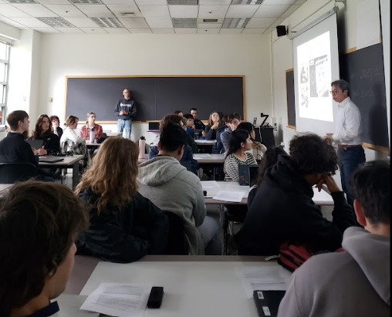
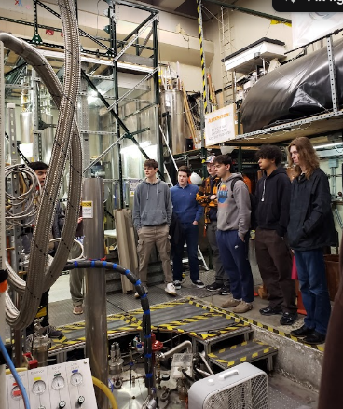
Spring Activities
We began the year with Masterclass 2025, held on March 29 at the University of Washington in Seattle. The event welcomed approximately 40 students from three Seattle public schools, one Tacoma public school, and a private school in downtown Seattle.
Participants toured the Center for Experimental Nuclear Physics and Astrophysics (CENPA), including its linear accelerator and dark matter research facility. Students engaged in hands-on activities, analyzing ATLAS Z-path data, which provided an authentic experience in particle physics research.
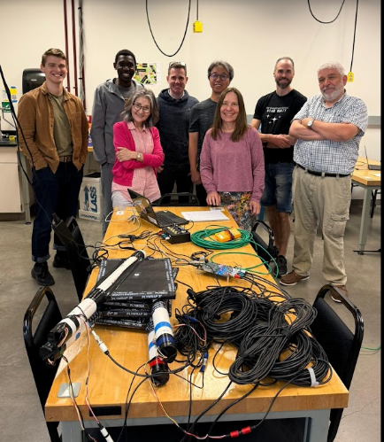
Summer Workshop
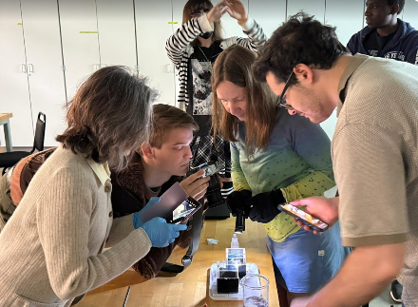
Our summer workshop, “Cosmic Ray Data, e-Lab Workshop – Advanced Studies,” took place from June 23–25. This three-day event was hosted by the Seattle QuarkNet Center and featured QuarkNet staff Kenneth Cecire and Nicole Preiser, along with UW mentor Shih-Chieh, lead teacher Tseveldorj Oyuntugs, and Dave Aplin.
Five teachers participated in activities such as:
- Cosmic ray tutorials and detector troubleshooting
- Cloud chamber experiments to identify particles by their tracks
- Classroom activities like Mean Lifetime Dice
- Data collection using muon detectors and subsequent analysis
Teachers also toured the UW Physics Department laboratories and shared instructional strategies to enhance classroom engagement.
Fall Activities
In the fall, the Seattle QuarkNet Center represented QuarkNet at the AAPT Annual Meeting at LIGO and the Washington State Science Teachers Conference, where we hosted a booth to showcase our programs and resources.
Additionally, Stadium High School and Lincoln High School in Tacoma participated in W2D2-25, engaging 150 students in analyzing ATLAS and CMS data, with approximately 60 events reviewed.
