Virginia QuarkNet Center 2024-2025 Activity Report
November 9, 2025

The Virginia QuarkNet Center currently has around 15 active high school teachers from Hampton, Newport News, Williamsburg, Richmond, and northern Virginia. One of our lead teachers (Maria Niland) moved to the Cayman Islands but is still active with our QuarkNet Center. Josh Erlich from William & Mary and Phil Rubin from George Mason University are the lead mentors. Lead teachers and LHC Fellows Mike Fetsko and Maria Niland have been sharing the bulk of the organizational responsibilities.

Masterclass 2025
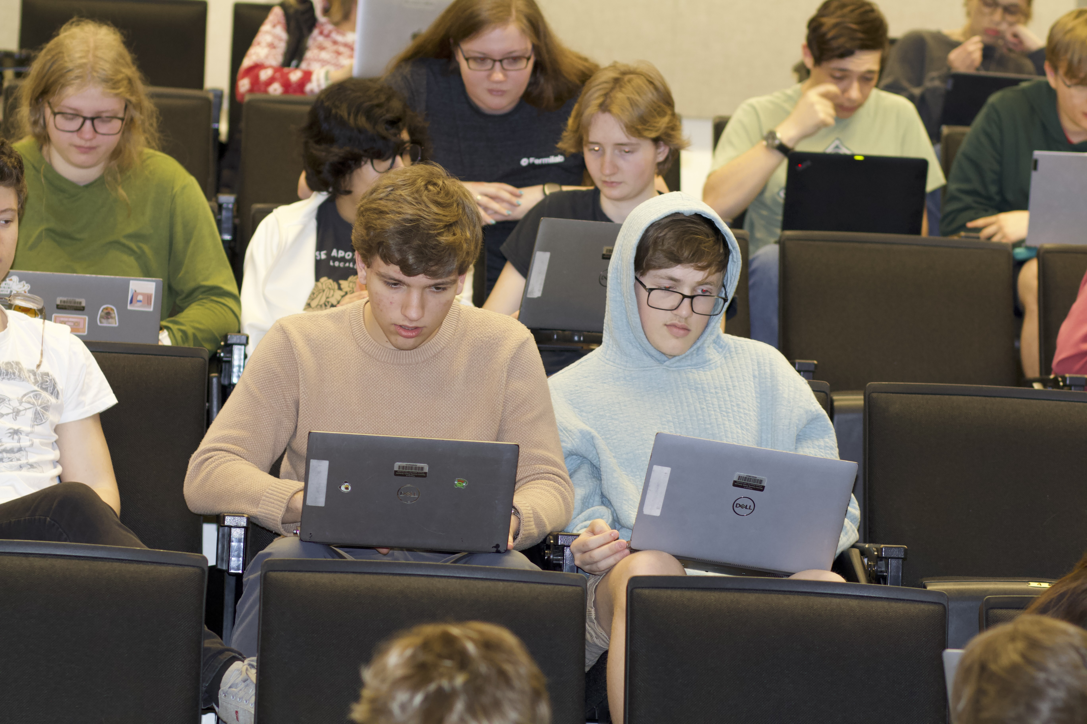
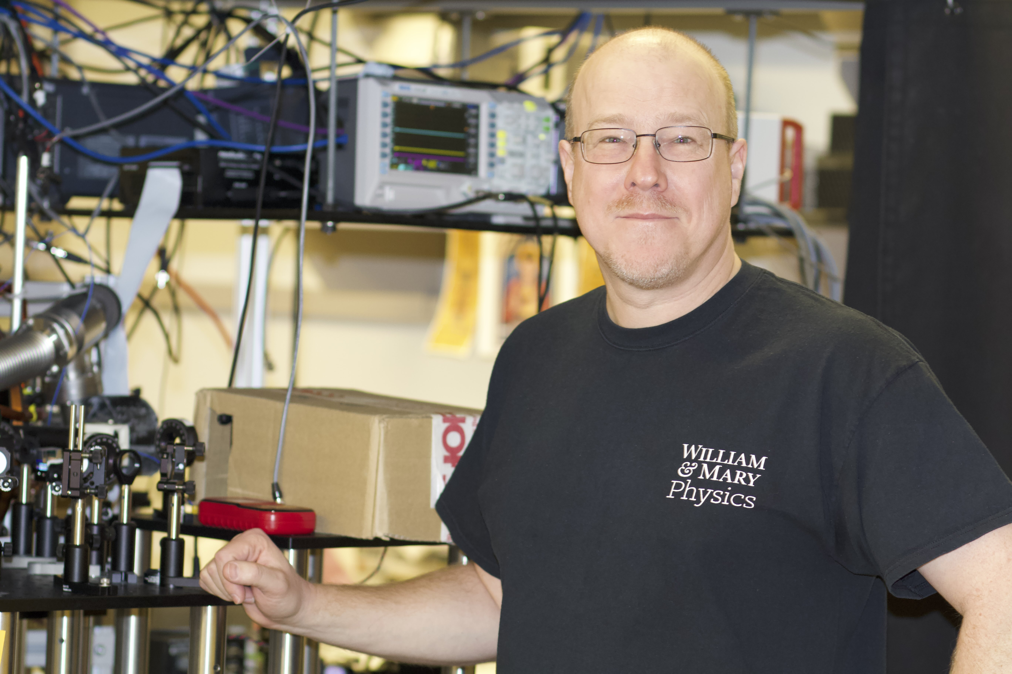
William & Mary hosted a CMS Masterclass on March 22, 2025 for around 50 students from VA and MD. In addition to the analysis of CMS data, students listened to a talk about particle physics, interacted virtually with a former Masterclass student currently studying at CERN, and toured several hadronic physics and AMO labs, and a NOvA experiment control room. Instead of the videoconference with Fermilab, Erlich discussed the results of the event analysis with the students.
Left: Students at 2025 Masterclass (William & Mary)
Right: Prof. Eugeniy Mikhailov shows off his lab to Masterclass students.

Workshops

The Virginia Center hosted a workshop on November 9, 2024 at The Steward School, with a number of curriculum-focused activities led by the teachers including discussion of World-Wide Data Day and AP Physics by Niland, a talk by Erlich, and a videoconference with Ken Cecire.

The Virginia Center also hosted a two-day QuarkNet-led Summer workshop on July 28-29, 2025 on cosmic watches (i.e. small cosmic ray detectors), led by QuarkNet Fellows Dan Kallenberg and Jeremy Wegner as facilitators of the workshop.

Other Activities
Virginia Center teacher Jeanette Morin gave a talk about the Virginia QuarkNet Center’s activities, at the October 2024 meeting of the Chesapeake Section of the American Association of Physics Teachers. Virginia Center teachers Marina Dyakova and Elena Kuchina also attended the meeting, and Kuchina chaired a parallel session.

As LHC Fellows, Maria Niland and Mike Fetsko work routinely on developing and improving QuarkNet activities such as Masterclass and Worldwide Data Day.

