LEAST ACTION PRINCIPLE
Boston QuarkNet
November 13, 2025
Rick Dower
NATURE
Philosophers have long expected Nature to be simple and, consequently, amenable to comprehension. Aristotle (c. 330 BCE) proclaimed, “Nature does nothing in vain.” Galileo (1638) applied the notion of simplicity in nature to mechanics when he stated, “in the investigation of naturally accelerated motion we were led, by the hand as it were, in following the habit and custom of nature herself, in all her various processes, to employ only those means which are most common, simple and easy . . . thus we may picture to our mind a motion as uniformly and continuously accelerated when, during any equal intervals of time whatever, equal increments of speed are given to it.” He was able to show experimentally that nature does, indeed, behave this way for objects in free fall with minimal air drag near Earth’s surface. Pierre de Fermat (1657) argued “There is nothing as probable or apparent as the assumption that Nature always acts by the easiest means, which is to say . . . by the shortest time.” Fermat supported his argument by showing that the refraction, as well as reflection and straight-line travel, for light could be explained by the single principle that light takes the least time to travel from point to point. Fermat’s theory was confirmed two centuries later by the experimental measurement of light speed in air and other substances by Fizeau and Foucault.

FORCE
Isaac Newton, in Principia (1687) Definitions IV, VII, and VIII, used uniform acceleration to define a force as something which produces a constant acceleration on an object of fixed mass. Since the weight (gravity) of an object produced a constant acceleration near Earth’s surface, gravity must be a constant force acting on the object. Other forces can be calibrated by balancing them against weights. Newton cautions against any metaphysical interpretation of force: “For I here design only to give a mathematical notion of those forces, without considering their physical causes.” With his definitions and Laws of Motion in hand, Newton went on to explore motions caused by a variety of mathematical forces. He deduced from astronomical observations that gravitational force between masses is not constant but is characterized by the now well-known expression, $F_{\text{g}}=\frac{Gm_{1}m_{2}}{r^{2}}$ . In Opticks (1704), Newton applied his ideas of force to the behavior of light rays, which he suggested were streams of particles, to explain straight-line travel, reflection, and refraction. He also suggested that diffraction of light passing through a narrow slit is due to forces exerted on the light particles by the substance surrounding the slit.
ACTION
Although Newton was much admired by European mathematicians, his notion of force was adopted with reluctance. Following Descartes, they hesitated to accept mysterious “action-at -a-distance” forces like gravity or magnetism for which there was no obvious mechanism. Among Newton’s admirers was Pierre Louis Moreau de Maupertuis. However, following Gottfried Leibniz (co-inventor, with Newton, of calculus), Maupertuis wanted to base physics, citing religious and metaphysical justifications, on a new quantity he called “action,” rather than force. In 1746, Maupertuis wrote, “in Nature, the amount of action necessary for change is the smallest possible. Action is the product of the mass of a body times its velocity times the distance it moves.” In mathematical terms, Maupertuis is stating that the path an object follows from point A to point B is given by minimizing the quantity $\int_{A}^{B}{(mv)ds}$ , where ds is an infinitesimal element of the path.
MINIMIZATION
Maupertuis may have been inspired by Leibniz’s dictum that God acts to produce “the best of all possible worlds,” Fermat’s demonstration of the utility of a minimum principle in optics and Johann Bernoulli’s success in applying an optical analogy to the following mechanical problem: “Given two points A and B in a vertical plane, find the path AMB down which a movable point M must, by virtue of its weight, fall from A to B in the shortest possible time.” This is the Brachistochrone (Greek: “shortest time”) problem of 1696. Galileo, in 1638, showed that the path was not a straight line, and he guessed that the path was the arc of a circle. One of Bernoulli’s two solutions to the problem imagines a light beam in a medium with a steadily decreasing refraction index and steadily increasing speed v (as indicated by Huygens’ wave model of light). Bernoulli supposed the medium consisted of thin slices of thickness, d, and refraction index, n_{i}, with steady increase in the speed at the lower boundary of each slice.
θ_{n}
θ_{n+1}
d
d
A
B
y

After falling from rest through n slices, with a vertical distance y = nd, the speed of the particle will begiven by Leibniz’s conservation of vis viva, where g = gravity acceleration,
$\frac{1}{2}mv^{2}=mgnd=mgy$ or $v=\sqrt{2gnd}=\sqrt{2gy}$
From Fermat’s relation for the index of refraction, which gives the least time path,
$\frac{\sin{θ_{\text{n+1}}}}{\sin{θ_{\text{n}}}}=\frac{v_{\text{n+1}}}{v_{\text{n}}}$ or $\frac{\sin{θ_{\text{n+1}}}}{v_{\text{n+1}}}=\frac{\sin{θ_{\text{n}}}}{v_{\text{n}}}=\text{constant }\text{for all slices}$.
Letting the slice thickness d → 0 (for a continuous medium) and combining the two relations above for the least time path yields: $\frac{\sin{θ}}{\sqrt{y}}=\text{constant.}$ Bernoulli recognized that this relation characterizes a cycloid curve. Isaac Newton and other European mathematicians offered different solutions with the same conclusion after Johann Bernoulli posed the problem as a public challenge.
CYCLOID
A cycloid is generated by the path of a point on a circle that rolls along a straight line. For a circle (radius = R) rolling below the x-axis the parametric equations for the (x,y) coordinates of the cycloid in terms of the angle of rotation (θ) of the circle are
x(θ) = Rθ – Rsin(θ) and y(θ) = – R + Rcos(θ) .
x
y
The center of the generating circle has moved along the x-axis distance Rθ.
D
The generating circle and dots on the resulting cycloid are shown in the figure above. Point C, where the circle touches the x-axis is directly above the center of the generating circle.
Point C is the center of a circle of radius AC that shares a tangent with the cycloid at point A. The tangent (AB) to that circle is perpendicular to AC and intersects the generating circle at B. If CB is a diameter of the generating circle, then AC ⊥ AB, and conversely, if AC ⊥ AB, then CB is a diameter.
Line CD is on the x-axis. The vertical distance DA is the negative y-coordinate of the cycloid.
CB is a diameter (2R) of the circle, C is directly above the generating circle center, and BC ⊥ CD. The sides of angle ABC are mutually perpendicular to angle ACD.
Therefore, ∠ ABC = ∠ ACD = α. Then $AC=BCsin{α=}2R\sin{α}$.
Finally, $y=\text{DA}=\text{AC}\sin{α=2R{\left(\sin{α}\right)}^{2}}$. Thus, the equation: $\frac{\sin{α}}{\sqrt{y}}=\frac{1}{\sqrt{2R}}=\text{ constant}$, is characteristic of a cycloid, as Johann Bernoulli recognized.

EULER AND MINIMIZATION
Maupertuis’ principle of least action was disputed by some mathematicians for its theological claims, and Maupertuis was personally attacked by Voltaire. However, his idea was supported by eminent Swiss Mathematician Leonhard Euler. In his A Method for Finding Curved Lines having some Properties of Maximum and Minimum (1744), Euler showed how to minimize Maupertuis’s action, with the restrictions that what we now call mechanical energy is conserved, and the endpoint times, as well as positions, are specified.
Euler developed the calculus of variations to find the extremum of the integral of a function f of y, dy/dx, and x. Let $J=\int_{x_{1}}^{x_{2}}{f\left[y\left(x\right), \acute{y\left(x\right), x)}\right]dx}$. Euler showed that the function f that produces the extreme (typically minimum) value of J must satisfy the relation:
$\frac{∂f}{∂y}-\frac{d}{dx}\left(\frac{∂f}{∂\acute{y}}\right)=0$, where $\acute{y}=\frac{dy}{dx}$ . Euler applied his results to show that Maupertuis’s Least Action Principle, with the added proviso that energy is conserved (no dissipative forces, such as friction, act), can produce Newtonian gravitational orbits.

THE BRACHISTOCHRONE REVISITED AS A MINIMUM PROBLEM
Suppose we want to find the path that takes the shortest time between two points A (0, 0) and B (x, y) in a vertical plane for a bead with mass m that starts at rest and slides without friction along a wire. The x-axis is horizontal and positive to the right. The y-axis is vertical and positive downward. The gravity force on the bead is F_{g} = mg downward. The constraining force exerted by the wire does no work on the bead.
A
Kinetic energy of the bead = T = mv²/2
x
Potential energy of the bead = V = –mgy
Total energy of the bead = E = T + V = mv²/2 – mgy = 0
B
y
Speed along the path = $v=\sqrt{2gy}$
The transit time to go from A to B is $t=\int_{0}^{y_{\text{B}}}{\frac{ds}{v}=\int_{0}^{y_{\text{B}}}{\frac{\sqrt{{dx}^{2}+{dy}^{2}}}{\sqrt{2gy}}=\int_{0}^{y_{\text{B}}}{{\left(\frac{{{(dx}/{dy)}}^{2}+1}{2gy}\right)}^{\frac{1}{2}}dy}}}$.
To find the path f(x, y) for minimum time, we use Euler’s 1744 condition (x and y variables interposed) for the $\frac{∂f}{∂x}-\frac{d}{dy}\left(\frac{∂f}{∂\acute{x}}\right)=0$, where $\acute{x}=\frac{dx}{dy}$ . Here, $f={\left(\frac{{\acute{x}}^{2}+1}{2gy}\right)}^{\frac{1}{2}}$ .
Since f is a function of $\acute{x}$ but not of x, $\frac{∂f}{∂x}=0$. Then $\frac{d}{dy}\left(\frac{∂f}{∂\acute{x}}\right)=0 \text{, and }\frac{∂f}{∂\acute{x}}=\text{ constant}$.
By choosing constant = $\frac{1}{\sqrt{4gR}}$ , we get $\frac{∂f}{∂\acute{x}}=\frac{1}{\sqrt{2gy}}\frac{\acute{x}}{\sqrt{{\acute{x}}^{2}+1}}=\frac{1}{\sqrt{4gR}}$ .
Squaring both sides of the last equation and simplifying, we get $\acute{x}=\frac{y}{\sqrt{2Ry-y^{2}}}$ .
Changing variables to the cycloid equation for y from page 4 (with the sign reversed since y is positive downward), we get y = R(1-cosθ) and dy = Rsinθdθ .
Substituting the change of variables, integrating $x=\int{\acute{x}dy}$ , and carrying out the necessary algebra yields the cycloid equation for x, x = R(θ – sinθ).

MAUPERTIUS – REFRACTION
How did Maupertuis justify his Least Action Principle? As Fermat before him sought to explain all known optics by a single principle of least travel time, Maupertuis sought to explain both optics and mechanics by a single principle of least action. In 1744 he derived the Cartesian-Newtonian accounts of light refraction (light travels faster in denser media) from his principle, and in 1746 he derived the equilibrium condition for two masses on a lever. These and other successful applications of his least action principle convinced Maupertuis that his principle was universal.
To account for refraction, Maupertuis supposed that a light beam in medium A starts at point A, travels to point P, on the interface between medium A and medium B, then on to point B in medium B. Light speed in medium A is v_{A}, and light speed in medium B is v_{B}.
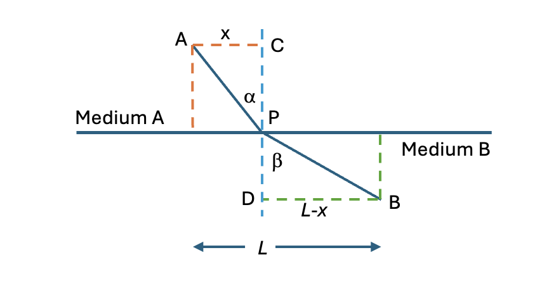
We want to find the position of point P on the boundary so that the path from A to P to B has the minimum of the Maupertuis action (S). CD is perpendicular to the boundary. Dashed lines in the diagram are drawn from A and B parallel and perpendicular to the boundary.
The A to B distance along the boundary is L. ∠ APC = α. ∠ BPD = β.
S/m = v_{A}(AP) + v_{B}(PB) = $v_{\text{A}}\sqrt{x^{2}+{(\text{PC})}^{2}}+v_{\text{B}}\sqrt{{(\text{L}-x)}^{2}+{(\text{PD})}^{2}}$
At the minimum,$\frac{d(\frac{S}{m})}{dx}=0$ Thus, $\frac{v_{\text{A}}(x)}{\sqrt{x^{2}+{(\text{PC})}^{2}}}+\frac{v_{\text{B}}(\text{L}-x)(-1)}{\sqrt{{\text{(L}=x)}^{2}}+{(\text{PD)}}^{2}}=v_{\text{A}}\sin{α-v_{\text{B}}\sin{β}=}0$.
This is Newton’s refraction relation $\frac{\sin{α}}{\sin{β}}=\frac{v_{B}}{v_{\text{A}}}=\text{constant}$. It is the inverse of the Fermat-Huygens speed ratio that, over one hundred years later, was found to match experimental measurements. Maupertuis did not know his speed ratio was incorrect. For him the constant ratio demonstrated that his action principle could account for the constancy of the ratio of sines of angles in refraction.

MAUPERTIUS – LEVERS
The law of the lever has been known since at least the time of Archimedes (c. 250 BCE). That law answers the question, “Where must the fulcrum be placed to balance weights at either end of a beam of negligible weight?” Maupertuis was able to derive the law from his least action principle, as follows.

Consider weights W₁ (mass = m₁) and W₂ (mass = m₂) at either end of a negligible weight horizontal beam of length L.
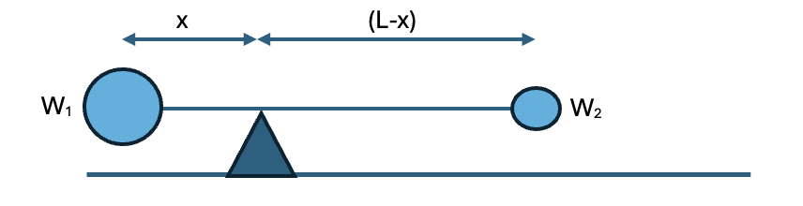
W₁ is distance x from the fulcrum. W₂ is distance (L- x) from the fulcrum.
Consider a slight rotation through angle Δθ about the balance point in time Δt. The total action experienced by the system is
S = m₁v₁s₁ + m₂v₂s₂ = m₁(xΔθ/Δt)(xΔθ) + m₂[(L-x)(Δθ/Δt)][(L-x)Δθ].
S is a minimum where $\frac{dS}{dx}=0.$ $\frac{dS}{dx}=\frac{m_{1}\left(2x\right){\left(Δθ\right)}^{2}}{Δt}+\frac{m_{2}2(L-x)(-1){(Δθ)}^{2}}{Δt}=0$
This equation yields the well-known law of the laver: m₁x = m₂(L-x) .
With these successes and a few others, Maupertuis was satisfied that he had found a universal law.

LAGRANGE
Joseph-Louis Lagrange generalized Euler’s calculus of variations applied to the least action principle in 1760/61. He introduced the symbol ”δ” to indicate an infinitesimal change in a function itself in contrast to the “d” notation that indicates an infinitesimal change in the value of a variable within a function. Lagrange showed that finding the path that minimizes the action between beginning and end point events in space and time is equivalent to minimizing $\int{\left(KE-PE\right)dt }$between the two points for paths where energy is conserved. In his Méchanique analytique (1788) Lagrange showed how all mechanics (statics and dynamics) can be derived from D’ Albert’s principle of virtual work and Euler’s principle of least action. He extended his methods to generalized coordinates (q_{i}), beyond Euler’s use of x, y, and z Cartesian coordinates, to describe the position of elements of the system under consideration.
Just over 100 years after Newton’s Principia, replete with diagrams and Newton’s geometric reasoning, Lagrange stated in his Preface to Méchanique analytique, (1788) “No figures [diagrams] will be found in this work. The methods I present require neither constructions nor geometrical or mechanical arguments, but solely algebraic operations [including calculus].” His hope may have been that the solution to problems in physics would no longer depend on clever geometric reasoning. The solution process itself would become almost mechanical.

LEAST ACTION – LAGRANGIAN
Suppose we have a one-dimensional system with motion along the x-axis, mass m, and speed v, and all forces dependent only on position (and not on velocity). Forces of constraint, e. g. normal force of a surface or tension force of inextensible string or a rigid rod, may act along the perpendicular to the path the system follows, but they do zero work, and do not change the energy of the system. Then the potential energy of the system can be described by a scalar field V(x), and the force acting on an object at any point in the field is given by $F=-\frac{dV}{dx}$. [Recall ΔV = –F(Δx)]. We use Lagrange’s notation for what we now call potential and kinetic energy: Potential Energy = V, Kinetic Energy = T. We assume that for the system under consideration total mechanical energy E = T + V = constant.
We desire to find the path x(t) between spacetime (t, x, y, z) points A and B followed by the system under the action of the force. Consider a path [s(t) + η(t)] that varies slightly from the true path, s(t). According to Maupertuis, we want to find a path for which the action (S) is stationary, i. e. unchanging to first order, when the path is changed slightly, so that the action is an extreme, typically a minimum. In other words, we want $S\left(x+η\right)-S\left(x\right)=δS=δ\int_{\text{A}}^{\text{B}}{mv\left(ds\right)=0}$,
where ds is the infinitesimal increment of length along the path.
Note ds = (v)dt, where dt is the infinitesimal time increment as mass m travels along a path.
Then $δ\int_{\text{A}}^{\text{B}}{mv\left(ds\right)=δ\int_{\text{A}}^{\text{B}}{mv\left(vdt\right)}}=δ\int_{\text{A}}^{B}{mv^{2}dt=δ\int_{\text{A}}^{\text{B}}{2Tdt=δ\int_{\text{A}}^{\text{B}}{(T+E-V)dt=0}}}$
Continuing, we have $δ\int_{\text{A}}^{\text{B}}{\left(T+E-V\right)dt=δ\int_{\text{A}}^{\text{B}}{\left(T-V\right)dt}+δ\int_{\text{A}}^{\text{B}}{Edt=0}}$.
Now, $δ\int_{\text{A}}^{\text{B}}{Edt=δ\left(Et\right)=Eδt+tδE=0+0}$, if we consider only paths with the same travel time (δt = 0) and constant energy (δE = 0).
The result $δ\int_{\text{A}}^{\text{B}}{\left(T-V\right)dt=δ\int_{\text{A}}^{\text{B}}{Ldt=0}}$
is called Hamilton’s Principle after William Rowan Hamilton (1834 and 1835). Hamilton called the quantity L = T – V the Lagrangian in homage to Lagrange. The Lagrangian results from the effort to find a quantity to be minimized that involves both kinetic and potential energy, each of which vary while the total energy (E) remains constant.
Lagrange showed that when the total mechanical energy of a system is conserved, and the potential energy is dependent on position but not on velocity of the components of the system, i. e. forces like friction or air drag are negligible, the equations of motion that minimize the total action for the system are solutions to the Euler-Lagrange equations
$\frac{∂L}{∂q_{\text{i}}}-\frac{d}{dt}\left(\frac{∂L}{∂{\dot{q}}_{\text{i}}}\right)=0$ or $\frac{d}{dt}\left(\frac{∂L}{∂\dot{q_{\text{i}}}}\right)=\frac{∂L}{∂q_{\text{i}}}$ , i = 1, 2, 3, …
where the q_{i} variables are the generalized coordinates of the system and ${\dot{q}}_{\text{i}}=\frac{dq_{\text{i}}}{dt}$ .
The Lagrange formulation of mechanics is often simpler than the Newtonian (force vector) formulation because the Lagrangian is a scalar quantity independent of coordinate systems.

EULER-LAGRANGE EQUATION AND NEWTON’S LAW IN 1-DIMENSION
The equivalence of the Euler-Lagrange equation and Newton’s force law equation is easy to show when the force is related to a simple 1-dimensional potential V(x): $F=-\frac{dV}{dx}$ , dependent only on position and not on velocity, as required for the application of the Euler-Lagrange equations. We use Newton’s dot notation for time derivatives:
$v=\dot{x}=\frac{dx}{dt}\text{ and }a=\dot{v}=\ddot{x}$ . Combine L = T – V = mv²/2 – V and $\frac{∂L}{∂x}-\frac{d}{dt}\left(\frac{∂L}{∂\dot{x}}\right)=0$
to obtain $\frac{∂\left(\frac{m{\dot{x}}^{2}}{2}-V(x)\right)}{∂x}=\frac{d}{dt}\left\{\frac{∂\left(\frac{m{\dot{x}}^{2}}{2}-V(x)\right)}{∂\dot{x}}\right\}$ ⇒ $-\frac{dV}{dx}=\frac{d(m\dot{x})}{dt}$ ⇒ $F=m\ddot{x}=ma$
Modern theorists have found the Lagrangian formulation advantageous because it can be applied to fields as well as particles. Deriving the outcomes of interactions in a system then becomes a matter of finding the appropriate Lagrangian for the system. A few simple examples follow.

PROJECTILE MOTION
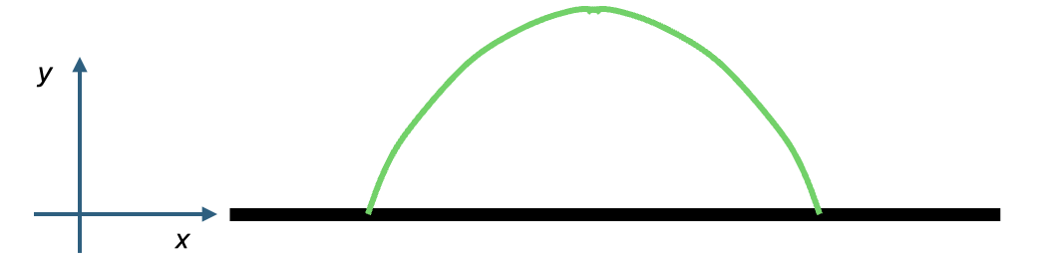
To find the equations of motion of a simple projectile, let $L=T-V=\frac{m\left(v_{x}^{2}+v_{y}^{2}\right)}{2}-mgy$, with x and y the horizontal and vertical coordinates, respectively.
For the Euler-Lagrange equations, let q₁ = x and q₂ = y.
Then $\frac{d}{dt}\left(\frac{∂L}{∂\dot{x}}\right)=\frac{∂L}{∂x}$ ⇒ $\frac{d}{dt}\left(\frac{m\left(2\dot{x}\right)}{2}\right)=0$ ⇒ mv_{x} = constant ⇒ v_{x} = constant for m = constant.
And $\frac{d}{dt}\left(\frac{∂L}{∂\dot{y}}\right)=\frac{∂L}{∂y}$ ⇒ $\frac{d}{dt}\left(\frac{m(2\dot{y}}{2}\right)=-mg$ ⇒ $m\ddot{y}=-mg$ ⇒ a_{y} = – g = constant.
These two equations for horizontal and vertical coordinates yield the parabolic path of a simple projectile, well-known since Galileo first derived it.

BALL ROLLING (WITHOUT SLIPPING) ON A RAMP INCLINED AT ANGLE θ TO HORIZONTAL
Consider a solid ball of uniform density with radius R and mass m. The ball is located on a ramp that is raised at angle θ from the horizontal. Let angle φ represent the angle of rotation of the ball from some initial position. The gravitational acceleration is g.
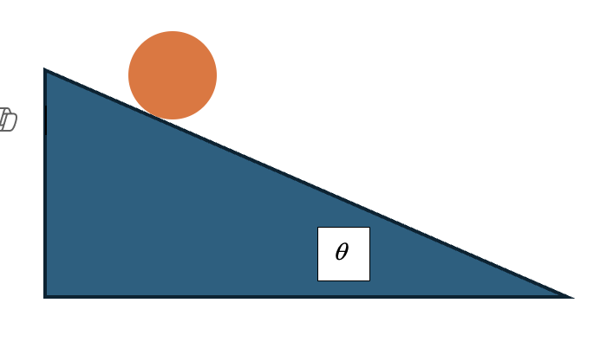
Then $ω=\frac{dϕ}{dt}=\dot{ϕ}$. The kinetic energy of the ball is composed of the translational kinetic energy of its center on mass (CM) plus its rotational kinetic energy about its center of mass (located at the center of the ball):
$T=\frac{mv^{2}}{2}+\frac{Iω^{2}}{2}=\frac{m{(Rω)}^{2}}{2}+\frac{\frac{2MR^{2}}{5}ω^{2}}{2}=\left(\frac{7}{10}\right)mR^{2}ω^{2}=\left(\frac{7}{10}\right)mR^{2}{\dot{ϕ}}^{2}$.
Set the potential energy of the ball V = 0 at the initial position of the ball. The distance the ball rolls along the ramp is Rφ, and the potential energy of the ball is V = – mg(Rφ)sinθ .
$L=T-V=\left(\frac{7}{10}\right)mR^{2}{\dot{ϕ}}^{2}+mgRϕ\sin{θ}$
The equation of motion along the ramp is given by $\frac{d}{dt}\left(\frac{∂L}{∂\dot{ϕ}}\right)=\frac{∂L}{∂ϕ}$ .
$\frac{d}{dt}\left(\frac{7mR^{2}(2\dot{ϕ})}{10}\right)=mgR\sin{θ}$ ⇒ $R\ddot{ϕ}=\left(\frac{5}{7}\right)g\sin{θ}$ ⇒ $a=\left(\frac{5}{7}\right)g\sin{θ}$ down the ramp, as would be obtained by a Newtonian analysis with the parallel axis theorem for the moment of inertia of the ball about the point of contact of the ball and ramp.

SIMPLE PENDULUM
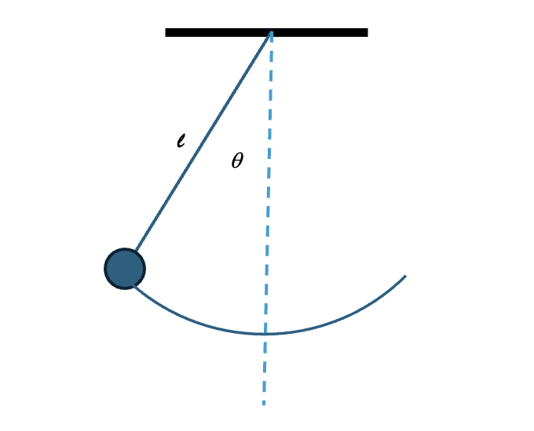
A point mass m is suspended from support by a string of length l. The angle between the string and vertical is θ. The mass is released from some initial angle $θ_{\text{0}}≤\frac{π}{2}$ to vertical, and the gravitational acceleration is g.
$T= \frac{mv^{2}}{2}=\frac{m{\left(l\dot{θ}\right)}^{2}}{2}=\frac{ml^{2}{\dot{θ}}^{2}}{2}$ and $V=mgl(1-\cos{θ})$, with V = 0 when θ = 0 .
The equation of motion for the pendulum mass is given by $\frac{d}{dt}\left(\frac{∂L}{∂\dot{θ}}\right)-\frac{∂L}{∂θ}=0$, where L = T – V.
$\frac{d}{dt}\left(\frac{∂L}{∂\dot{θ}}\right)=\frac{d}{dt}\left(ml^{2}\dot{θ}\right)=ml^{2}\ddot{θ}$ and $\frac{∂L}{∂θ}=-mgl\sin{θ}$
Therefore, the equation of motion is $ml^{2}\ddot{θ}+mgl\sin{θ}=0$ or $\ddot{θ}+\frac{g}{l}\sin{θ}=0$ .
When θ is small, sin θ ≅ θ, and the equation of motion becomes $\ddot{θ}+\frac{g}{l}θ=0$ with the familiar solution $θ\left(t\right)=θ_{0}\cos\left(\sqrt{\frac{g}{l}}t\right)$ , where θ₀ is the initial angle from which the pendulum is released at time t = 0. The oscillation period is then $T≅2π\sqrt{\frac{l}{g}}$ .

The Lagrangain approach yields results equivalent to the results of Newtonian analysis without dealing with forces of constraint such as the normal force exerted by the ramp or the tension force exerted by the pendulum string in the examples above. In contrast to Newtonian analysis, Lagrangian analysis applies only where energy is conserved and no dissipative forces, e.g. friction or air drag, act.
Conceptually, the Newtonian analysis seems to provide a clear explanation for motion in terms of cause and effect: the change in motion of an object at any instant is due to the forces acting on the object at that instant. The principle of least action seems to suggest that nature chooses, out of all possible paths for an object, the path between two points that optimizes (minimizes) the integrated action, as if nature somehow compares the action along all possible paths before the motion occurs. However, to minimize the total action integrated over a path, the action must be a minimum for each infinitesimal part of the path. So, the optimal path need not be known in advance for the path taken to have the least total action associated with it. In Newtonian analysis, the forces acting on an object at any point determine its acceleration, subsequent velocity, and subsequent position. In Lagrangian analysis, the Lagrangian function at each point determines the object’s subsequent position. While Newtonian analysis with vector forces may be more familiar to physics students, Lagrangian analysis, dependent only on scalar expressions for energy, is widely applicable, often mathematically simpler, and is more commonly used in advanced physics theories.

YouTube Videos Related to Brachistochrone and Least Action Principle

Vsauce: https://www.youtube.com/watch?v=skvnj67YGmw
“The Brachistochrone” (25:56)
Building a cycloid and comparing path times. (1:30 – end)

3Blue1Brown: https://www.youtube.com/watch?v=Cld0p3a43fU&t=696s
“The Brachistochrone. With Steven Strogatz” (16:01)
(00:00 – 13:07) Deriving the math of a cycloid from geometry., followed by a math challenge.

Derek Muller
Veritasium: https://www.veritasium.com/videos/2025/1/17/the-strange-physics-principle-that-shapes-reality
Or https://www.youtube.com/watch?v=Q10_srZ-pbs&t=1s
“The Closest We’ve Come to a Theory of Everything”
or “The Strange physics principle that shapes reality” (30:44)
History - brachistochrone – least time for optics – Johann Bernoulli - Maupertuis – Least Action - Euler – Lagrange – least action updated
Veritasium: https://www.youtube.com/watch?v=qJZ1Ez28C-A&t=1571s
“Something Strange Happens When You Trust Quantum Mechanics” (33:00)
Least time and light – Black body and Planck history – quantum of action – Feynman and all paths – diffraction grating an “all paths” proof?

Curt Jaimungal
Theory of Everything: https://www.youtube.com/watch?v=XcY3ZtgYis0
“Debunking the “All Possible Paths” Myth: What Feynman Really Showed” (14:09)
(00:00 – 10:00) Quantum wave function is in configuration space, not 3-d real space.
PBS Spacetime: https://www.youtube.com/watch?v=Q_CQDSlmboA
“Is ACTION the Most Fundamental Property in physics?” (19:40)
(00:00 – 14:00) Development of Fermat’s least time, then Newton and Lagrange up to Dirac and Feynman.

PBS Spacetime https://www.youtube.com/watch?v=PHiyQID7SBs&t=191s
“The Equation That Explains (Nearly) Everything!” (16:42)
(00:0 – 15:10) Reference to of the classical Lagrangian and description of the terms in the Standard Model Lagrangian density formula.

Physics Explained https://www.youtube.com/watch?v=v_VAyZopHIk
“What does the Principle of Least Time Have to Do with Quantum Physics?” (24:52)
(00:00 – 18:30) Development of Fermat’s least time principle.
(18:30 – 24:52) Application to quantum physics and light travel.

Up and Atom https://www.youtube.com/watch?v=dPxhTiiq-1A
“Principle of Least Action – A Beautiful way to look and the world” (12:26)
(00:00 – 09:30) Physics formulations as models of reality (a map not the territory) with a comparison of Newtonian and least time models..

A. Rojo and A. Bloch, The Principle of Least Action: History and Physics, Cambridge University Press, Cambridge, 2018, p. 2.
Galileo Galilei, Dialogues Concerning Two New Sciences, H. Crew and A. de Salvo trans., 1914, Dover Publications, New York, pp. 160-161.
Rojo and Bloch, Ibid.
Sir Isaac Newton’s Mathematical Principles of Natural Philosophy and His System of the World, F. Cajori, trans., Univ. of California Press, Berkeley, 1962, pp. 2, 4.
Ibid. p. 5.
Rojo and Bloch, Ibid.
Ibid. p. 51.
J. Marion, Classical Dynamics of Particles and Systems, Academic Press, New York, 1965, p. 202.
Rojo and Bloch, Ibid,, pp. 62-67.
Ibid. pp. 60-61.
Ibid., p. 90.
Ibid.
J. L. Lagrange, Analytical Mechanics, A. Boissonnade and V. N. Vagliente, trans. And ed., Kluwer Academic publishers, Dordrecht, 1997, p. 7.
C. Lanczos, The Variational Principles of Mechanics, 4th ed., Dover Publications, Inc., New York, 1970, p. 113. Also, Marion, Classical Dynamics, 1965, p. 217.

